To attain the aim of a totally autonomous driving car, the robot vehicle must have a thorough understanding of its surroundings. One aspect of the puzzle is onboard sensors, radars, and cameras. To provide a global perspective, additional data from surrounding vehicle sensors, intelligent traffic management systems (TMS), and pedestrians were collected. It is also necessary to establish a global traffic-information network. Getting this information across V2X is responsible for delivering air to all entities. Taking a broad picture of the vehicle's own circumstances It is conceivable to drive autonomously in the presence of these factors and nearby traffic. Information that is required is based on onboard sensors and V2X data, which are then analyzed by a sensor-fusion algorithm.

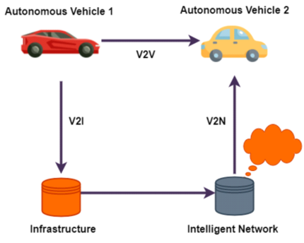

**Figure 1:** Autonomous Cross Road Infrastructure Scenario

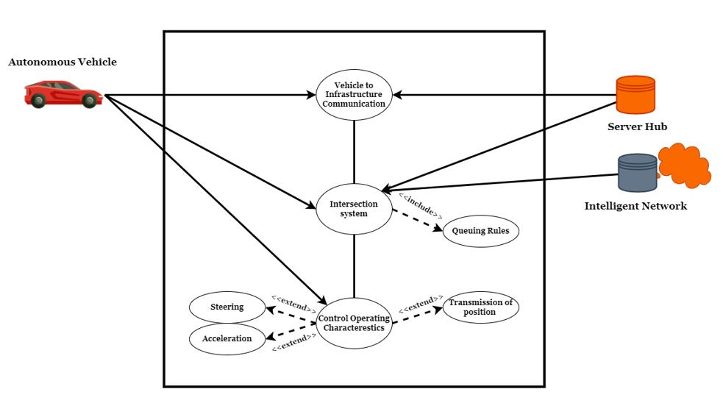

**Figure 2:** Autonomous Cross Road Infrastructure Use Case Diagram

• **Vehicle to Server Hub:** Shared information between automobiles and roadside units (RSU) or intelligent roadside stations is referred to as vehicle server or infrastructure communication. By delivering information or directives to vehicles or receiving appropriate sensor data from them, the roadside infrastructure dynamically regulates traffic in real-time.

• **Vehicle to Intelligent Network:** Communication is in charge of broadcasting global information to all cars or streaming data to high-bandwidth-demanding apps. To put it another way, V2N refers to a vehicle's non-real-time capable connection to the Internet or cloud computing services. Traditional TMS are ill-equipped to deal with tomorrow's major issues. When it comes to road crossings, this is especially true. Changing the color of traffic signals from green to red on a regular basis prevents them from adapting flexibly to changing traffic loads. As a result, the proposed use case is built on a variety of smart city ideas and use cases that are backed by a V2I system.